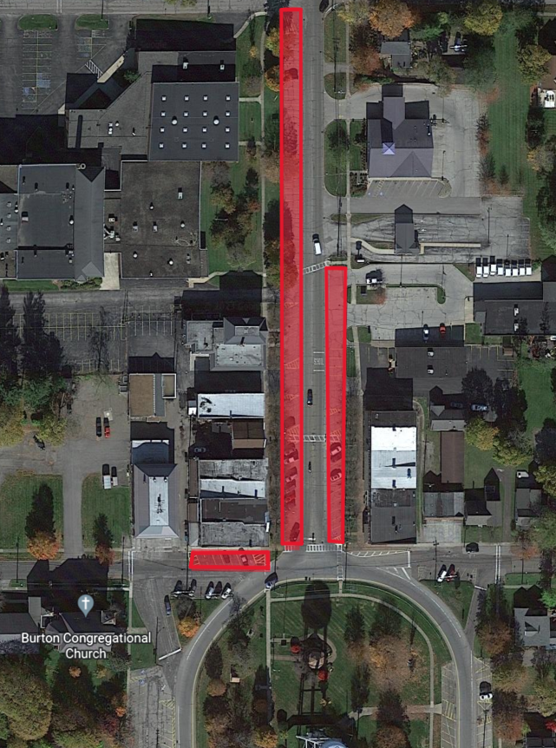

No parking on N. Cheshire St., or in the parking lot on Spring St. that is against the building between the hours of 11p and 5a.

Spring St.

N. Cheshire St.

N